Submitted by-

Name- Ishan Rawat

SAP ID- 500087524

Roll no- R2142201888

# Application Containerization and Orchestration Lab

# Experiment –1

Procedure:

**Step 1: Download and Install Oracle Virtual Box 5.x and Vagrant 2.2.7.**

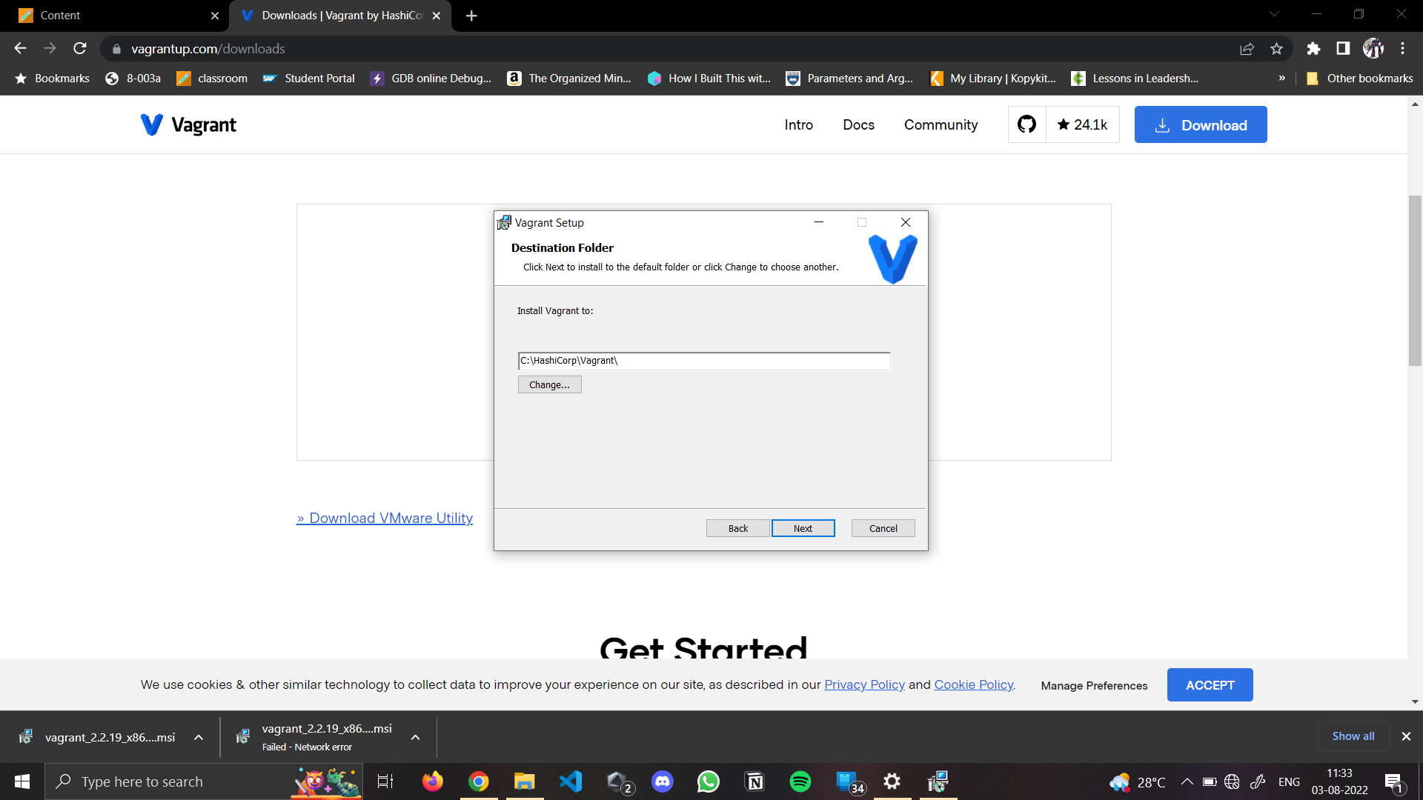

**Step 2: Check working of Vagrant using vagrant --version command.**

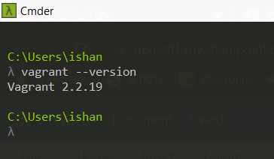

**Step 3: Create a new directory using CMD.**

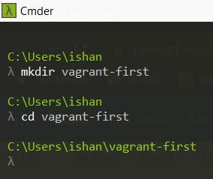

**Step 4: Run vagrant init command**

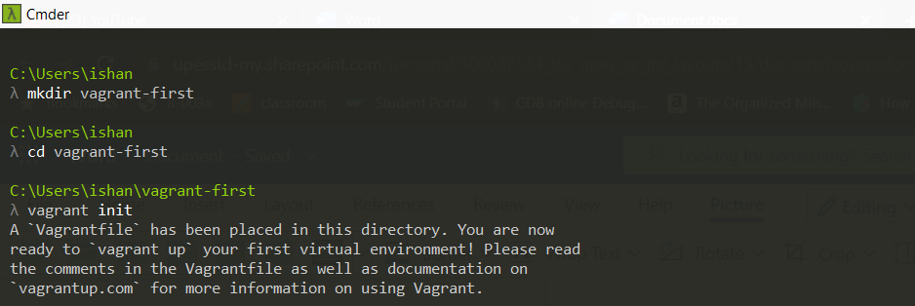

**Step 5: Edit vagrantfile and add ubuntu/xenial64 in box tag.**

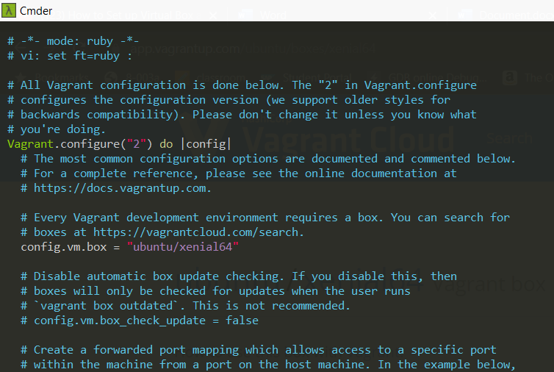

**Step 6: Run vagrant up command**

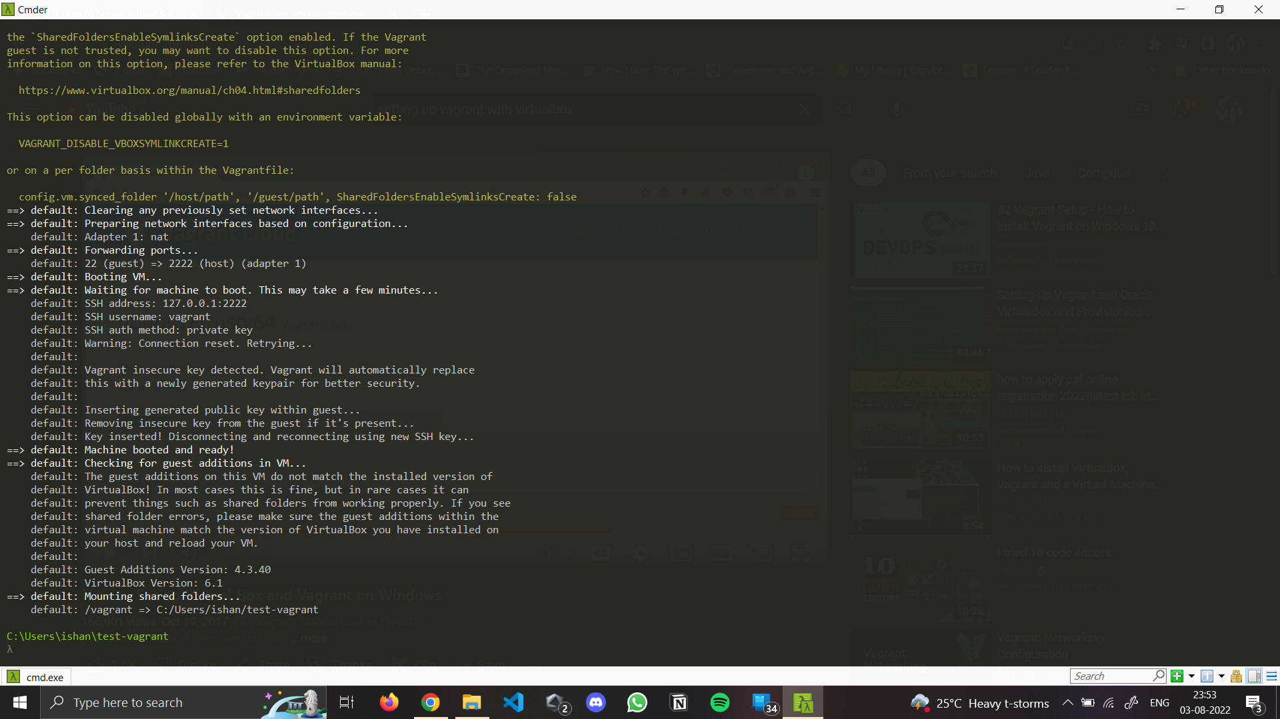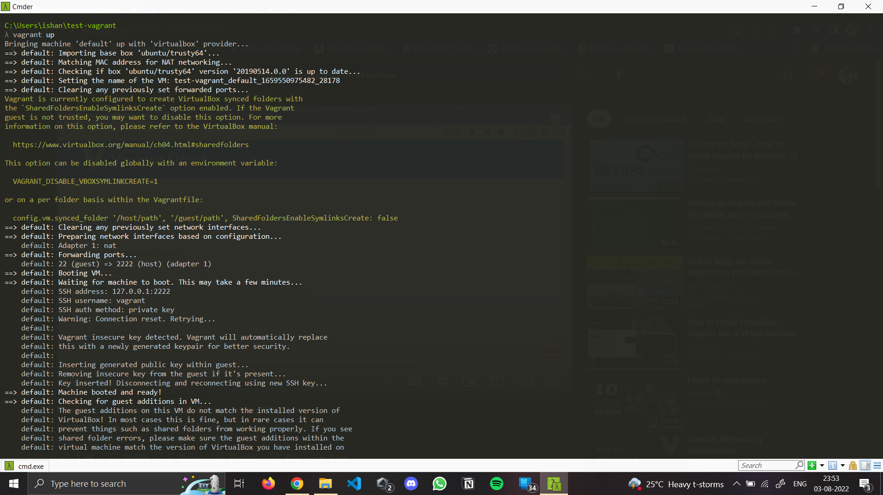

**Step 7: Run vagrant SSH command**

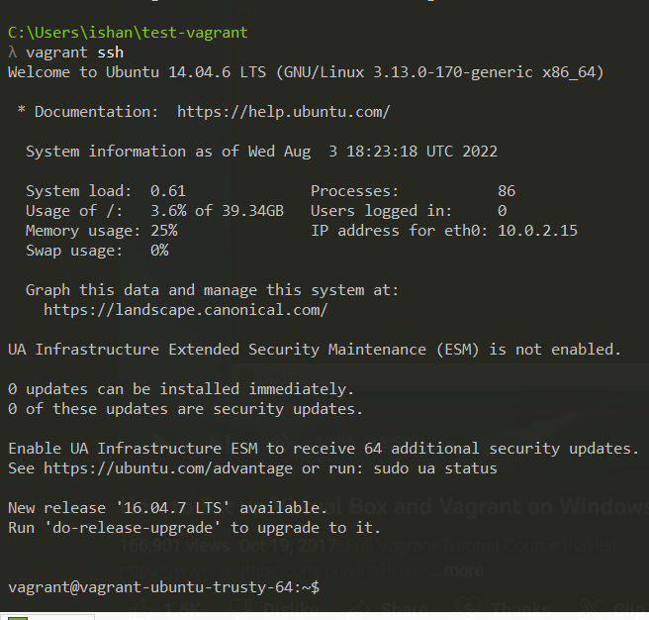

**Step 8: Run Vagrant Halt to stop VM**

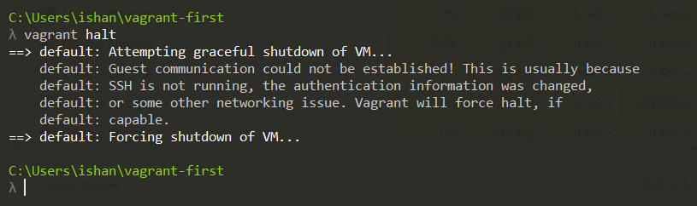

**Step 9: Run Vagrant Destroy to delete VM**

